**Name: NEHA ANTONY**

**Roll No:23**

**Batch:MCA-B**

**Date:08-04-2022**

**ADVANCED DATABASE MANAGEMENT LAB**

**Experiment No.: 3**

**Aim**

To familiarize DDL Commands- ALTER,DROP,TRUNCATE,RENAME

**QUESTION**

1. Create a table emp with attributes empno number(4)as primary key, ename char(10),hiredate,  salary, commission

insert 5 rows of data

2 .Modifying the structure of tables

a.Add new columns: sal number(7,2)

b.Dropping a column from a table: sal

c.Modifying existing column :ename varchar2(15)

d.Renaming the tables: emp to emp1

e.truncating the tables:emp1

f.Destroying tables:emp

3.Create a table stud with sname varchar2(20) primary key , rollno number(10) not null,dob  date not null

4. Create a table student as regno number (6), mark number (3) check constraint (mark >=0 and  mark

<=100));

In table student add check constraint(length(regno<=4))

5. Create a table cust with(custid number(6) constraint unique, name char(10)

**PROCEDURE**

1. CREATE TABLE emp(EMPNO INT(4) PRIMARY KEY, ENAME CHAR(10), HIREDATE DATE, SALARY INT(5),COMMISSION INT(5));

INSERT INTO emp(EMPNO,ENAME,HIREDATE,SALARY)

VALUES (101,'RAMESH','1980-01-17',5000),(102,'AJAY','1985-07-05',5000),

(103,'RAVI','1981-08-12',1500),(104,'Nikesh','1983-03-03',3000),

(105,'Ravi','1985-07-05',3000);

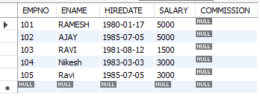

2.

a) ALTER TABLE emp ADD column sal int ;

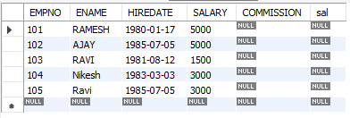

b) ALTER TABLE emp DROP COLUMN sal;

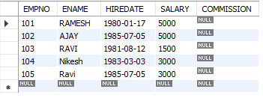

c) ALTER TABLE emp MODIFY ename VARCHAR(15);



d) RENAME table emp to emp1;



e) TRUNCATE TABLE emp1;

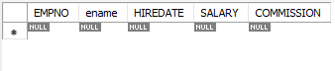

f) DROP TABLE emp1;



3. CREATE TABLE stud(sname varchar(20) PRIMARY KEY, rollno int NOT NULL, dob date NOT NULL);

SELECT * FROM stud;

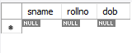

4. Create table student (regno int, mark int(3) constraint b check (mark >=0 and mark <=100));

SELECT * from student;

.

5. CREATE TABLE cust (custid int UNIQUE, name char(10));

